GAME INFO SHEET
Phoenix Paradise

Thunderkick Malta LTD
Version 1.0
2022-06-09

DISCLAIMER
No part of this document may be reproduced, transmitted or in any other way distributed without the prior written permission from Thunderkick Malta Ltd All technologies, designs, implementations, trade secrets and business models described herein is the intellectual property of Thunderkick Malta Ltd and/or it’s partners And is provided for information purposes only.
This document is provided “as is” without any warranty concerning its accuracy or quality. In no event will Thunderkick Malta Ltd be liable for direct or indirect damages resulting from incidental defects or inaccuracies in this document.
Thunderkick Malta Ltd reserves the right to review and Modify digital copies of this document at any time without prior notice.
The Thunderkick name, the Thunderkick logotype, game brands, services and product names are registered trademarks And/or service marks Of Thunderkick Malta Ltd, Registered within the european union.
Contact
Thunderkick Malta Limited
The Bastions office no 2
Emvin Cremona Street
Floriana FRN 1281
Malta
business@thunderkick.com
www.thunderkick.com
DOCUMENT HISTORY
VERSION | DATE | AUTHOR | COMMENT
1.0 | 2022-06-09 | Jörgen Åström | Initial Version

CONTENTS
1 INTRODUCTION 1
1.1 Phoenix Paradise 1
2 SPLASH SCREEN 2
3 MAIN GAME 3
3.1 Introduction 3
3.2 Pay Lines 3
3.3 Wild symbol 4
3.4 Wild Payline Multipliers 4
3.5 Mystery Wild Activation 5
3.6 Walking Wilds Feature 5
4 FREE SPINS BONUS GAME 6
4.1 Description 6
4.2 Free Spins Bonus Game Outro 6
5 PAY TABLE 7
5.1 Page 1 7
5.2 Page 2 7
5.3 Page 3 8
5.4 Page 4 8
5.5 Page 5 9
5.6 Page 6 10
5.7 Page 7 12
6 SYMBOLS 13
7 FEATURE BUY 17
8 PAYOUT 18
8.1 Return to Player (RTP) 18
9 Phoenix Paradise GAME RULES 19

INTRODUCTION

Phoenix Paradise
Phoenix Paradise is a 3x5 video slot with 15 fixed pay lines. The game features Wilds, Wild Payline Multipliers, Mystery Wild Activation, Walking Wilds Feature and a Bonus Game with free spins and retriggers. The theoretical return to player is 96.13%.
PARAMETER | VALUE
Game | Phoenix Paradise
Game-ID  See integration manuals for details on how to use this parameter.  (also referred to as gameName in the seamless wallet API) | tk-s1-g50-96
Required aspect ratio | 16:9
Recommended dimensions | 1280 x 720 or 1024 x 576  Custom values can be used as long as the aspect ratio is kept at 16:9
RTP (theoretical payout) | 96.13%
RTP (Feature buy) | 96.33%
Reels | 5
Pay Lines | 15
Bonus Game | Yes
Volatility (square root of variance) | 8.56 (High)
Max exposure | 10000x

SPLASH SCREEN
The intro shows the features in Phoenix Paradise.
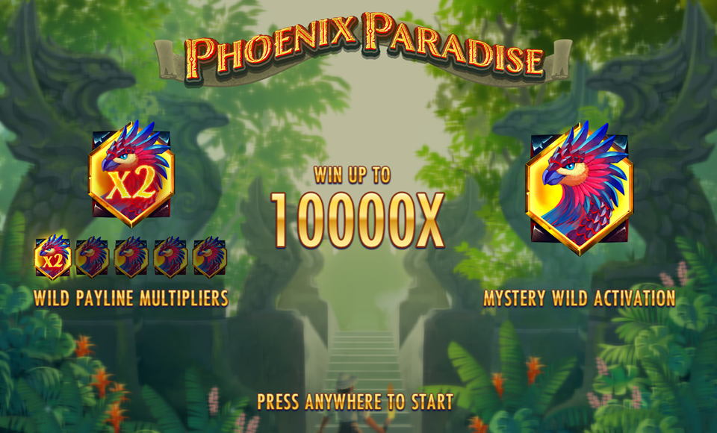

MAIN GAME

Introduction
The main game is started when the splash screen is closed by the player.
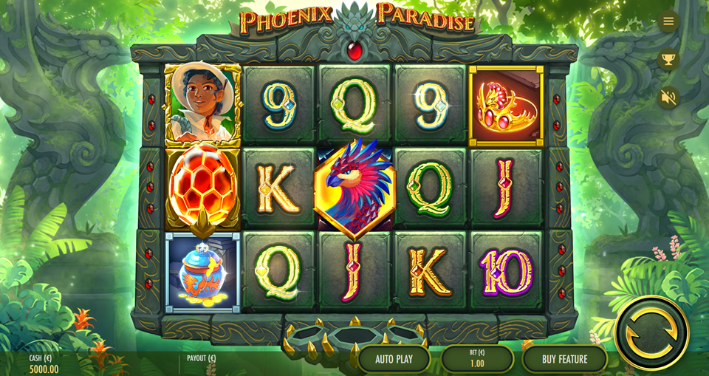

Pay Lines
Symbols landing in sequence from far left to right, in the patterns specified in the pay table.
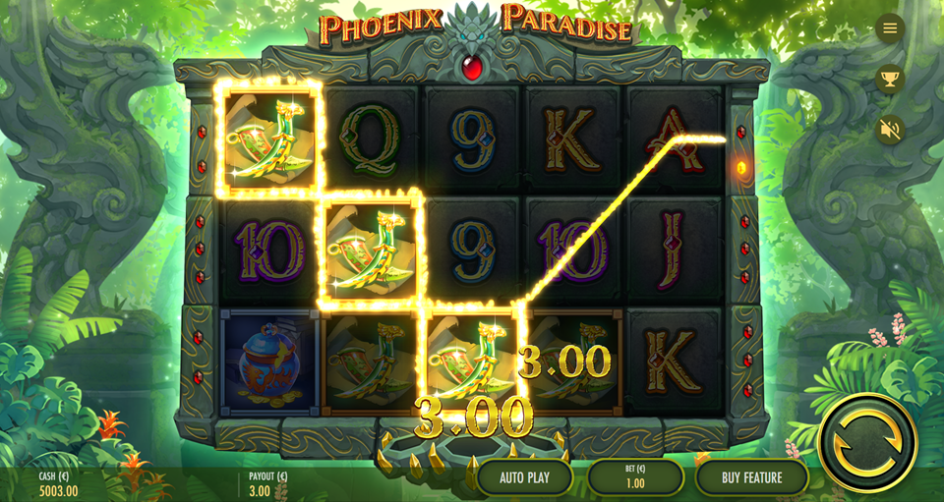

Wild symbol
The Wild symbols substitute for all other symbols except the Scatter symbol.
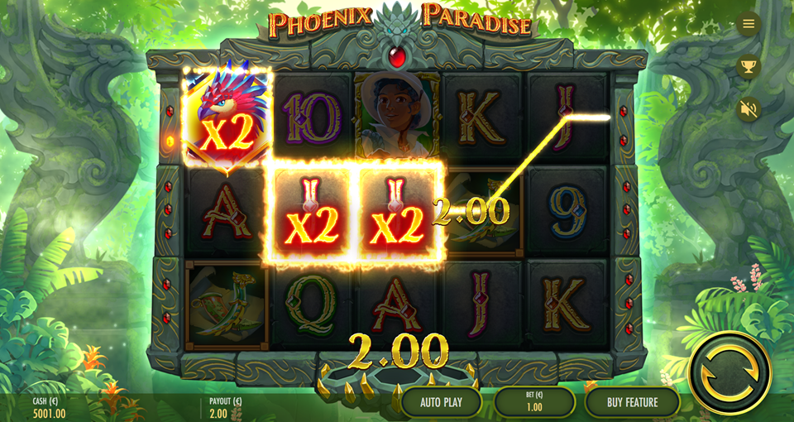

Wild Payline Multipliers
The Wild symbols substitutes for any other symbol except the scatter symbol.
Any pay line including a Wild symbol will have a multiplier based on the number of wilds included in the pay line.
1 Wild symbol in a pay line grants 2x multiplier.
2 Wild symbols in a pay line grants an 4x multiplier.
3 Wild symbols in a pay line grants an 8x multiplier.
4 Wild symbols in a pay line grants a 16x multiplier.
5 Wild symbols in a pay line grants a 32x multiplier.
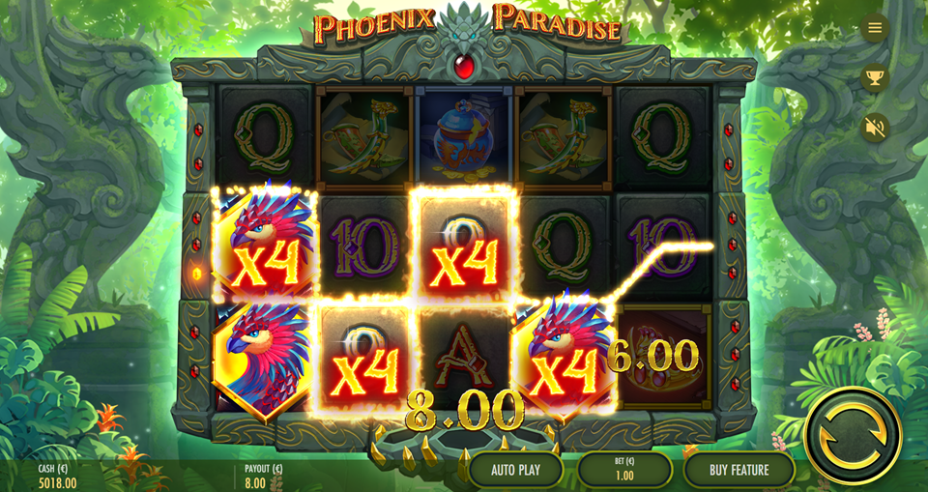

Mystery Wild Activation
In the base game the Mystery Wild Activation feature could randomly trigger and transform all Wilds into Walking Wilds for the remaining of the game round. In the Bonus Game all Wild symbols are always Walking Wild symbols.
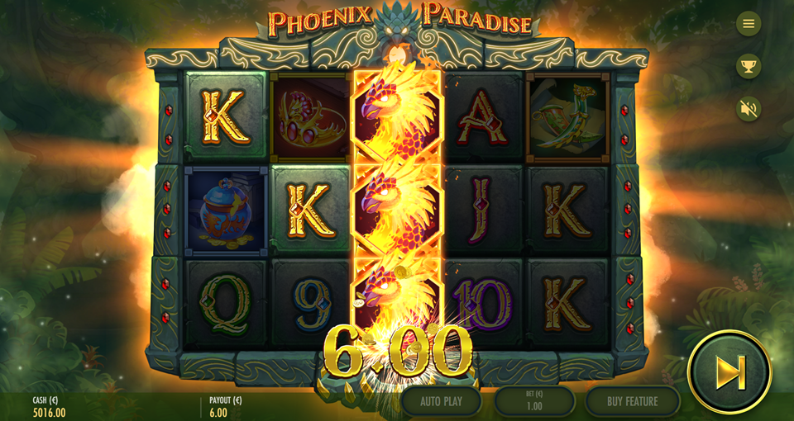

Walking Wilds Feature
The Walking Wilds feature grants respins and will trigger when the Walking Wild symbol appears on any reel. For each respin the Walking Wild(s) will move 1 reel to the left, or if already on the leftmost reel they will disappear from the game area. The Walking Wild respins will continue until there are no more Walking Wilds left in the game area.
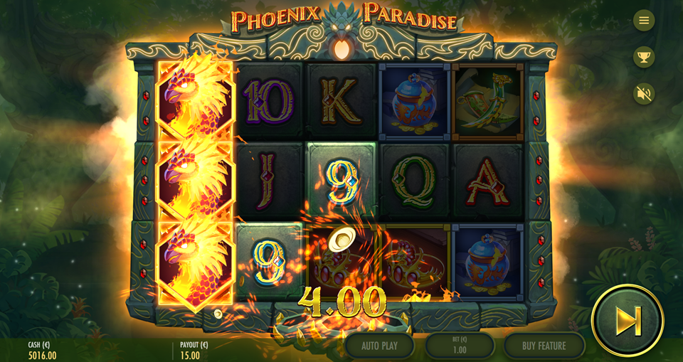

FREE SPINS BONUS GAME

Description
When the Bonus meter is filled with 3 Scatter symbols the Bonus Game is won or retriggered, awarding 8 or 4 free spins respectively. The Bonus meter is reset between each spin and each free spin.
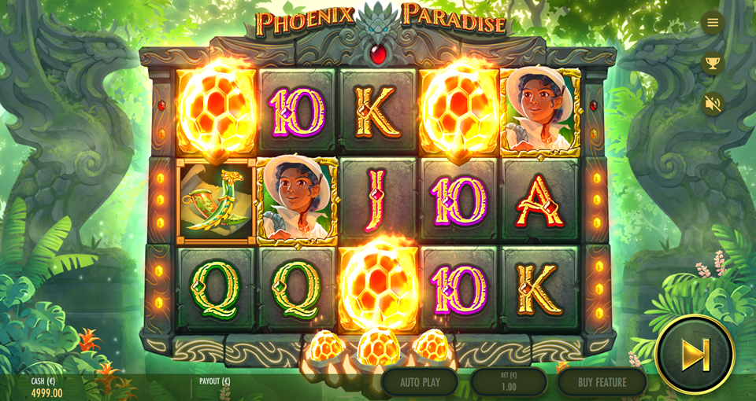

Free Spins Bonus Game Outro
The Bonus Game Outro displays the total win of the Bonus Game.
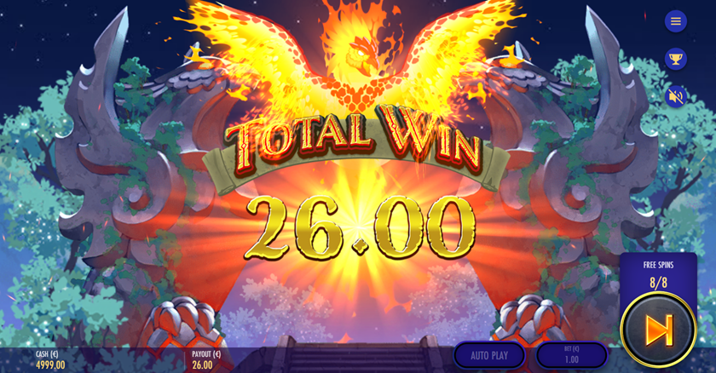

PAY TABLE
The pay table lists all features, symbols, pay values and win combinations in the game.

Page 1
Page 1 describes the Wild symbol.
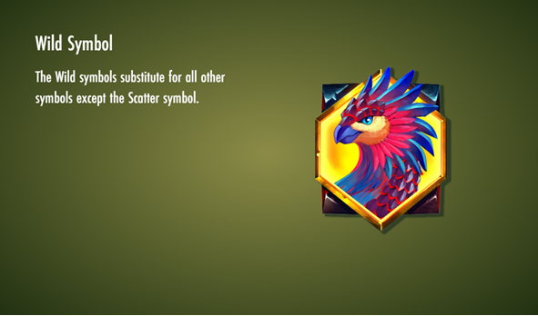

Page 2
Page 2 describes the Wild Payline Multipliers feature.
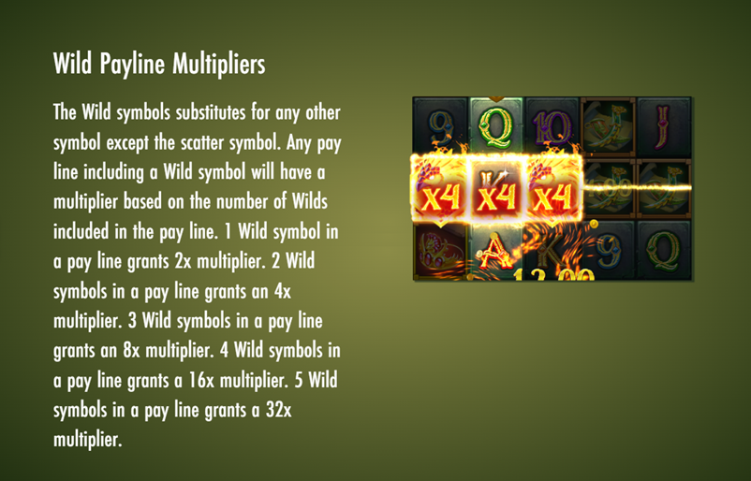

Page 3
Page 3 describes the Mystery Wild Activation feature.
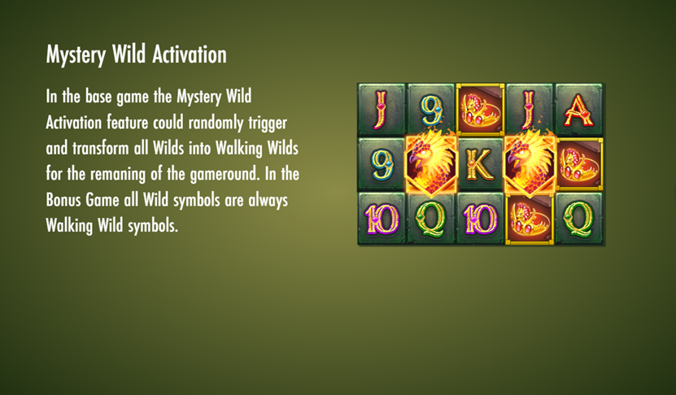

Page 4
Page 4 describes the Walking Wilds feature.
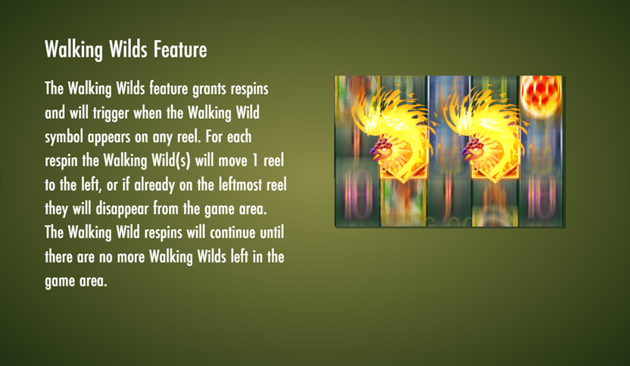

Page 5
Page 5 describes the Free Spins Bonus Game.
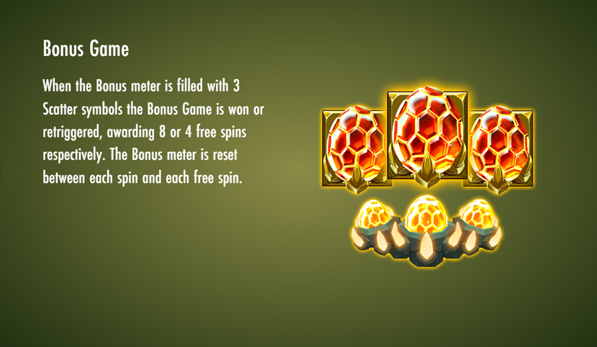

Page 6
Page 6 is the Pay Table and displays the symbol values relative to the current bet.
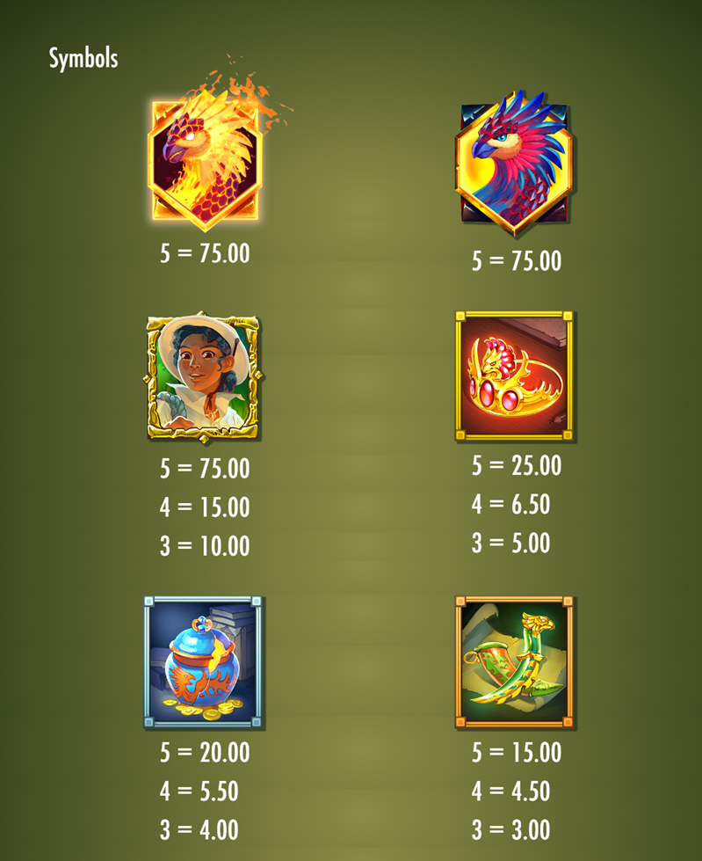
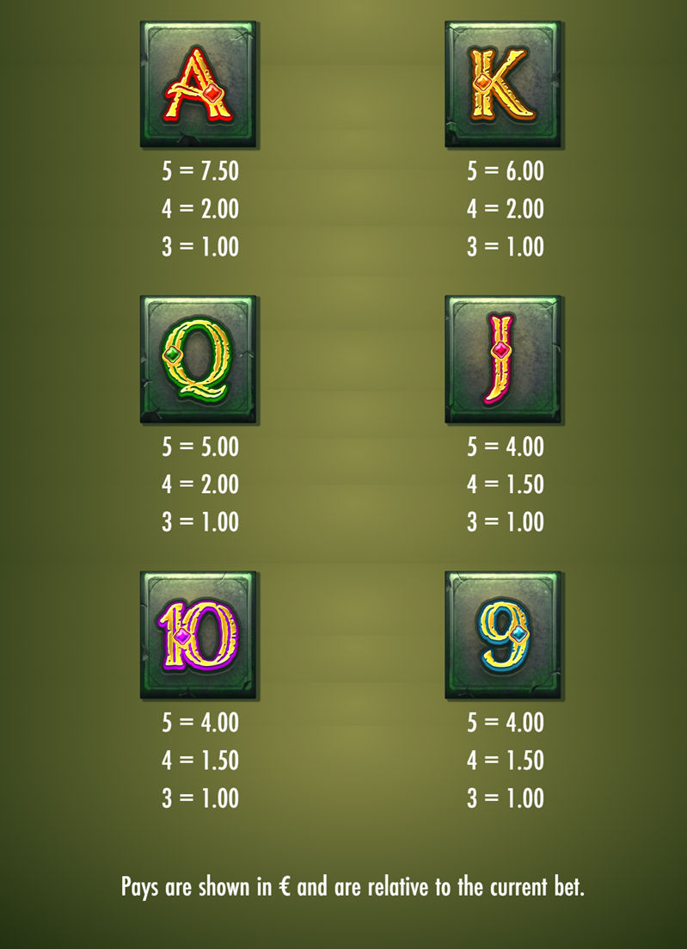

Page 7
Page 7 displays the pay lines in the game.
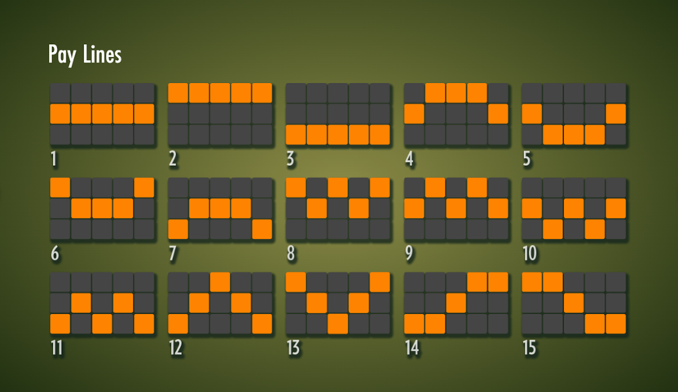

SYMBOLS
There are 13 symbols available in Phoenix Paradise. Each symbol has a unique identification number.
SYMBOL NUMBER | GRAPHIC | DECRIPTION
1 |  | High – Adventurer
2 |  | Mid – Green Dagger
3 |  | Mid – Blue Urn
4 |  | Mid – Red Tiara
5 |  | Low – A
6 |  | Low – K
7 |  | Low – Q
8 |  | Low – J
9 |  | Low – 10
10 |  | Low – 9
11 |  | Normal Wild Phoenix
12 |  | Walking Wild Fiery Phoenix
13 |  | Bonus Scatter

FEATURE BUY
A feature buy option may be purchased at a cost that is a multiple of the current bet size. A purchase starts a spin with an outcome containing at least 3 Scatter symbols. Theoretical RTP is 96.33%.
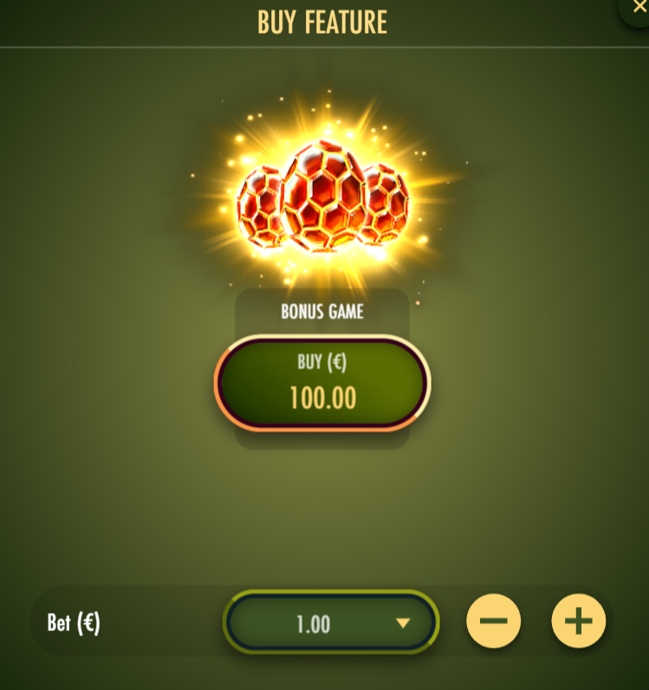
All outcomes from a feature purchase pays according to the pay table and in relation to the bet size.
The feature buy functionality may not be available in all markets.

PAYOUT

Return to Player (RTP)
The theoretical player return percentage for Phoenix Paradise is 96.13%. There are no features or settings that the player can change that will affect the payout (i.e.: configurable number of pay ways or size of bet that will affect hit frequencies).
There is no progressive jackpot available for this game.

Phoenix Paradise GAME RULES
Note: The Phoenix Paradise video slot is referred to as Phoenix Paradise, The Game or Game.
1. Phoenix Paradise is a 3x5 video slot with 15 fixed pay lines. The game features Wilds, Wild Payline Multipliers, Mystery Wild Activation, Walking Wilds Feature and a Bonus Game with free spins and retriggers. The theoretical return to player is 96.13%.
2. A game round is started with the action button and plays the game with the selected bet level.
3. Auto play plays the game automatically for the number of game rounds selected in the auto play page. This feature may not be available.
4. All game payout and win combinations are paid out according to the pay table.
5. All wins are presented and paid out in the selected currency.
6. Only the longest win per pay line is paid out, if in sequence from leftmost to right and in combinations according to the pay table.
7. The Wild symbols substitute for all other symbols except the Scatter symbol.
8. Wild Payline Multipliers: The Wild symbols substitutes for any other symbol except the scatter symbol.
Any pay line including a Wild symbol will have a multiplier based on the number of wilds included in the pay line.
1 Wild symbol in a pay line grants 2x multiplier.
2 Wild symbols in a pay line grants an 4x multiplier.
3 Wild symbols in a pay line grants an 8x multiplier.
4 Wild symbols in a pay line grants a 16x multiplier.
5 Wild symbols in a pay line grants a 32x multiplier.
9. Mystery Wild Activation: In the base game the Mystery Wild Activation feature could randomly trigger and transform all Wilds into Walking Wilds for the remaning of the gameround. In the Bonus Game all Wild symbols are always Walking Wild symbols.
10. Walking Wilds Feature: The Walking Wilds feature grants respins and will trigger when the Walking Wild symbol appears on any reel. For each respin the Walking Wild(s) will move 1 reel to the left, or if already on the leftmost reel they will disappear from the game area. The Walking Wild respins will continue until there are no more Walking Wilds left in the game area.
11. When the Bonus meter is filled with 3 Scatter symbols the Bonus Game is won or retriggered, awarding 8 or 4 free spins respectively. The Bonus meter is reset between each spin and each free spin.
12. The Bonus Game is played with the same bet as the spin that triggered the Bonus Game.
13. No bets can be altered during a game round.
14. In the event of game malfunction all affected bets and pays are rendered void.
15. All wins during a game round are added and presented at the end of the game round.
16. The maximum total bet multiplier for one game round is 10000x. If this limit is reached the game round will be terminated and no additional wins will be paid out.
17. A feature buy option may be purchased at a cost that is a multiple of the current bet size. A purchase starts a spin with an outcome containing at least 3 Scatter symbols. Theoretical RTP is 96.33%. All outcomes from a feature purchase pays according to the pay table and in relation to the bet size. The feature buy functionality may not be available in all markets.

